|  |  |  |
| --- | --- | --- |
|  | | |
| VML Demo – VML_MENA_Assessments_Engineering_Sitecore_Engineer | | |
| **Mahendra Shekhawat** |  |  |

# Introduction

## Project Overview

VML Demo website for assessment purpose, based given objectives.

## Purpose of this Document

The purpose of this document is to supply high level information required to understand the project.

## Document Audience

This document has one primary audience: reviewer with prior Sitecore knowledge.

# High Level

## Sitecore

This is a Sitecore 10.3, SPE and SXA implementation, using Docker, NextJS and headless services.

This project is not following all the best practices standard as primary objective to complete the given tasks with in the deadline.

### Templates –

* Implementation is done for the header component and templates are created under “vmldemo” folder in foundation and feature section in templates node –

### Renderings

* There are 3 Json Renderings created in the project –
  + **ContantCallOutWithSlider** – Showing static content on the website, want to make sure Tailwind is working fine
  + **Header** – Datasource driven component
    - Datasource Location and Datasource template is set on the component
  + **JssNextForm** – rendering for Sitecore forms
    - Datasource Location and Datasource template is set on the component

### Forms

* Content form is created under the forms section –

### Content

* There are two websites created under the headless tenant-

* Presentation is set on the home page of vmldemo website
  + Please use preview option to view the page

## Frontend Solution Structure

For renderings in Sitecore three NextJs components are created in the FED solution –

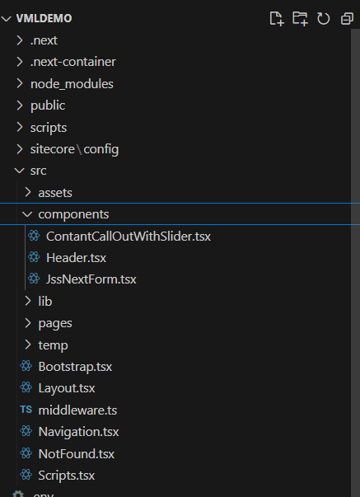

FED project location is “\src\vmldemo” on the root.

* For setup please follow the ReadME.md on the root
* Currently there is only one Branch - Main